NOTICE OF MEETING OF THE

COMMISSIONERS COURT OF FRIO COUNTY, TEXAS

On the 23rd day of May, 2022, at 3:00 p.m., the Commissioners Court of Frio County met in a special meeting with the following members either absent or present, to-wit: Arnulfo C. Luna, Frio County Judge was present; Joe Vela, Commissioner Pct 1 present; Richard “Dicki” Graf, Commissioner Pct 2 present; Raul Carrizales , Commissioner Pct 3 present; Jose Asuncion, Commissioner Pct 4 present; Joseph A. Sindon, Legal Counsel for Frio County Commissioners Court present; and Aaron Ibarra, Frio County Clerk present when the following meeting was held, to-wit:

I. Invocation and Pledge of Allegiance

II. Adopt Agenda

III. Old Business

**PRESENTATION**

**ACTION AGENDA ITEMS**

IV. General Discussion

V. Citizens To Be Heard

*Please note that the Rules of Procedure, Conduct and Decorum at Meetings of the Commissioners Court of Frio County, Texas limit each speaker to a maximum of three (3) minutes to make his or her remarks. Inappropriate conduct or comments during this time, including but not limited to disruptive behavior, insults, personal attacks, and inappropriate language, may result in the speaker being ordered to leave the meeting and forfeit any remaining speaking time. For more information regarding the above-mentioned rules, please see the complete Rules of Procedure, Conduct and Decorum at Meetings of the Commissioners Court of Frio County, Texas, which is available upon request.*

VI. New Business

**PRESENTATION**

**ACTION AGENDA ITEMS**

(1) Frio County Commissioners Court, requests:

Consider/take action on opening and selecting Request for Proposals (RFP) those received by the specified deadline for comprehensive grant writing services for Frio County.

(2) Hon. Mike Morse, Frio County Sheriff, requests:

MOTION: RAUL CARRIZALES

SECOND: JOSE ASUNCION

MOTION PASSED

Consider/Take action on running a request for sealed bids for the replacement of Frio County Building smoke purging systems located at the Frio County Jail. The request will run in the Frio Nueces Current once a week for the two weeks pursuant to Local Government Code Sec. 262.025. The ad will run in the Frio Nueces Current on May 26, 2022 and June 2, 2022. Sealed bids will be accepted in the Auditor’s office until 3:00pm, June 24, 2022. Bids will be opened during commissioner’s court on June 27, 2022 at 3:00pm.

**Bid Notice**

By order of the Commissioner’s Court of Frio County, Texas, and pursuant to Section 262.023 of the Texas Local Government Code, sealed requests for repair and or replacement of all smoke purge systems to meet all Texas Jail Standards requirements in all listed housing units (Exhibit A). Bids shall account for all hardware, and labor. All work must integrate with the currently operational and functioning system, as follows:

Location: UNIT B 8 individual cells and 1 day room

Location: UNIT C 8 individual cells and 1 day room

Location: UNIT D 8 individual cells and 1 day room

Location: UNIT I 24 Person group Unit

Location: UNIT J 24 Person group Unit

Location: UNIT P Single Cell (Violent Padded Unit)

The Frio County Jail is located at 502 S. Cedar St. in Pearsall, Texas. All bids will be received at the Frio County Auditor’s office, 500 E San Antonio Street, Pearsall, Texas 78061 until June 24, 2022 at 3:00 p.m. Bids received after the time indicated will be returned unopened. The bids will be opened and read aloud during the Commissioner’s Court meeting on June 27, 2022 at 3:00 p.m. Prospective bidders may contact Chief Deputy Pedro Salinas, 502 S. Cedar Street, Pearsall, Texas 78061; phone 830-334-3311, or by e-mail psalinas@friosheriff.org in regards to obtaining biding/proposal information. Bidder should use unit pricing and include any delivery costs. The County of Frio reserves the right to reject any and all Bids and to accept the Bid most advantageous to the County.

(3) Hon. Mike Morse, Frio County Sheriff, requests:

MOTION: RAUL CARRIZALES

SECOND: JOSE ASUNCION

MOTION PASSED

Consider and take necessary action on the selection of an Architect (DRG Architects, San Antonio) in accordance with Government Code 2254.004 for the planning and design of the Court Facility and Administration Addition at the Frio County Jail.

(4) Hon. Mike Morse, Frio County Sheriff, requests:

Discussion on the floorplan design and use of Carlos Segura’s soon to be vacated office and its future use for court house security.

(5) Hon. Mike Morse, Frio County Sheriff, requests:

Discussion on Possible policy regarding Abandoned Vehicle funding to subsidize private Frio County landowners suffering damages due to criminal pursuits initiated by the FCSO.

(6) Hon. Joe Vela, Frio County Commissioner, Precinct No. 1, requests:

Discussion regarding the installation of county-purchased vending machines.

WILL BE DONE SOON

(7) Hon. Joe Vela, Frio County Commissioner, Precinct No. 1, requests:

Discussion regarding the placement of dumpsters in Derby and the security of the lots where the dumpsters are to be placed.

(8) Hon. Joe Vela, Frio County Commissioner, Precinct No. 1, requests:

Discussion regarding the opening of county roads in Derby.

(9) Hon. Crystal Marquez, Frio County Auditor, requests:

9.1 Consider / take action on approving the acceptance of proposal number 67232 from Comet Signs for the purchase and installation of Lionel G. Trevino fabricated letters on the Frio County Sheriff’s Office.

9.2 If the proposal above is approved, consider / take action on signing a resolution authorizing Frio County Judge Arnulfo C. Luna to sign and enter into the same on behalf of Frio County, Texas.

MOTION: RAUL CARRIZALES

SECOND: JOE VELA

MOTION PASSED

(10) Hon. Crystal Marquez, Frio County Auditor, requests:

Consider / take action on the acceptance of donated funds in the amount of $2,300.00 from various sources to the Frio County Enrichment Committee.

MOTION: RAUL CARRIZALES

SECOND: JOSE ASUNCION

MOTION PASSED

(11) Hon. Crystal Marquez, Frio County Auditor, requests: **(HOLD)**

Discuss/take action on requesting bidding for phone and internet services.

(12) Tommy Navarro, Frio County Facilities Management Supervisor, requests:

12.1 Consider/take action on approving the Work Authorization No. 3 in the amount of $47,010.00 between Frio County and SJPA, LLC for design services to include site planning services for the Frio County Modular Office Building.

12.2 If the agreement is approved, consider/take action on signing resolution authorizing Hon. Arnulfo C. Luna, Frio County Judge, to sign same on behalf of Frio County.

$18,800

MOTION: RAUL CARRIZALES

SECOND: JOSE ASUNCION

MOTION PASSED

(13) Hon. Crystal Marquez, Frio County Auditor, requests:

Consider / take action on approving ARP Eligible Expenses for the Work Authorization #3 from SJPA for the site planning of the Frio County Modular Office Building for the amount of $47,010.00.

$18,800

MOTION: RAUL CARRIZALES

SECOND: JOSE ASUNCION

MOTION PASSED

(14) Hon. Crystal Marquez, Frio County Auditor, requests:

14.1 Consider / take action to approve the budget amendments to the FISCAL YEAR 2021-2022 Frio County Budget, list below:

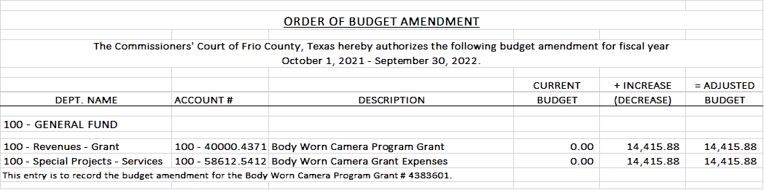

14.2 If the amendment is approved, consider/take action on signing order stating same.

MOTION: JOSE ASUNCION

SECOND: JOE VELA

MOTION PASSED

(15) Hon. Crystal Marquez, Frio County Auditor, requests:

15.1 Consider / take action to approve the budget amendments to the FISCAL YEAR 2021-2022 Frio County Budget, list below:

MOTION: JOSE ASUNCION

SECOND: RAUL CARRIZALE

MOTION PASSED

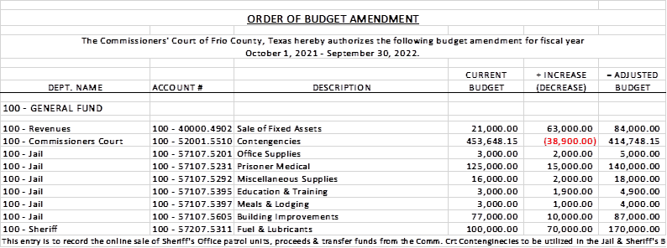

15.2 If the amendment is approved, consider/take action on signing order stating same.

(16) Hon. Richard Graf, Frio County Commissioner, Precinct No. 2, requests:

Consider/take action on setting county policy allowing Frio County Road and Bridge Employees to provide assistance to Frio County food distributions, policy regarding payment for said work, and for acceptance of donations to Frio County from the San Antonio Food Bank.

(17) Hon. Arnulfo C. Luna, Frio County Judge, requests:

MOTION: RAUL CARRIZALES

SECOND: JOSE ASUNCION

MOTION PASSED

Consider/take action on accepting the letter of resignation of David L. Cortinas, Frio County Veterans Service Officer, effective May 30, 2022.

(18) Roxana Garcia, P.E., Frio County Engineer, requests:

18.1 Consider/take action on approving and adopting resolutions granting permits to Trinity Operating (USG), LLC to lay, construct and maintain three (3) temporary (12”) water pipeline under the County Road 4670 Road right-of-way for a total permit fee of $450.00.

18.2 If the resolution is approved and adopted, then authorize Frio County Judge Arnulfo C. Luna to execute the permit on behalf of Frio County, Texas to Trinity Operating (USG), LLC.

MOTION: RAUL CARRIZALES

SECOND: JOSE ASUNCION

MOTION PASSED

(19) Roxana Garcia, P.E., Frio County Engineer, requests:

19.1 Consider/take action on approving and adopting resolutions granting permits to Barbara S. Ruel to lay bore, construct and maintain one (1) 3/4” water pipeline and one (1) 4” sewer pipeline under the County Road 4601 right-of-way for a total permit fee of $300.00.

MOTION: JOE ASUNCION

SECOND: JOE VELA

MOTION PASSED

19.2 If the resolution is approved and adopted, then authorize Frio County Judge Arnulfo C. Luna to execute the permit on behalf of Frio County, Texas to Barbara S. Ruel.

(20) Hon. Jose Asuncion, Frio County Commissioner, Precinct No. 4, requests:

MOTION: RICHARD GRAF

SECOND: JOE VELA

MOTION PASSED

Consider/take action on designating Honorable Crystal Marquez to receive training on the pay formula used by Dr. Werling for the 2022 Frio County salary study.

(21) Mary Perez, Frio County Human Resources Director, requests:

Consider/take action on the current Plan for the contract  renewal with Blue Cross and Blue Shield of Texas.

(22) Documents (resolutions, orders, contracts, etc.) to be signed.

REVIEWED SIGNED

(23) Allow bills payable

MOTION: RAUL CARRIZALES

SECOND: JOSE ASUNCION

MOTION PASSED

(24) Adjourn

MOTION: RAUL CARRIZALES

SECOND: JOSE ASUNCION

MOTION PASSED